Lab Sheet 2: **Java JDBC Lab Practical**

**Set Up MySQL Database**

1. Install MySQL (if you haven't already) and create a database for the lab.
2. Open MySQL Workbench or command line and execute the following SQL commands:

CREATE DATABASE employee_db;

USE employee_db;

CREATE TABLE employees (

id INT PRIMARY KEY AUTO_INCREMENT,

name VARCHAR(100),

position VARCHAR(100),

salary DECIMAL(10, 2)

);

INSERT INTO employees (name, position, salary) VALUES ('John Doe', 'Software

Engineer', 75000);

INSERT INTO employees (name, position, salary) VALUES ('Jane Smith', 'HR

Manager', 65000);

INSERT INTO employees (name, position, salary) VALUES ('Steve Brown', 'Team

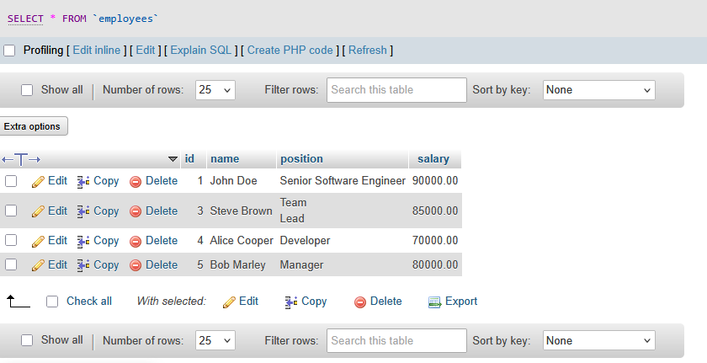Lead', 85000);

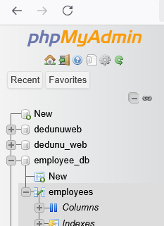

**Set Up NetBeans Project**

1. Open NetBeans IDE
2. Create a new Java application:

* Go to File > New Project.
* Select Java as the project type, and choose Java Application.
* Name your project JDBCExample.

1. Add MySQL JDBC Driver to your project:

* Right-click on the project in the Projects pane.
* Select Properties.
* In the Libraries tab, click Add JAR/Folder.
* Navigate to the location of your mysql-connector-java-x.x.xx.jar file and add it.

**Establish JDBC Connection**

1. Create a DatabaseConnection.java class to establish a connection to your database.

package jdbcexample;

import java.sql.Connection;

import java.sql.DriverManager;

import java.sql.SQLException;

public class DatabaseConnection {

private static final String URL ="jdbc:mysql://localhost:3306/employee_db"; // Database URL

private static final String USER = "root"; // Your MySQL username

private static final String PASSWORD = ""; // Your MySQL password

public static Connection getConnection() throws SQLException {

try {

// Load the JDBC driver

Class.forName("com.mysql.cj.jdbc.Driver");

// Return the database connection

return DriverManager.getConnection(URL, USER, PASSWORD);

}

catch (ClassNotFoundException | SQLException e) {

System.out.println("Connection failed: " + e.getMessage());

throw new SQLException("Failed to establish connection.");

}

}

}

**Perform CRUD Operations**

1. Create EmployeeDAO.java for CRUD Operations:

package jdbcexample;

import java.sql.*;

import java.util.ArrayList;

import java.util.List;

public class EmployeeDAO {

// Create an employee

public static void addEmployee(String name, String position, double salary){

String sql = "INSERT INTO employees (name, position, salary) VALUES (?,?, ?)";

try (Connection conn = DatabaseConnection.getConnection();

PreparedStatement stmt = conn.prepareStatement(sql)) {

stmt.setString(1, name);

stmt.setString(2, position);

stmt.setDouble(3, salary);

int rowsAffected = stmt.executeUpdate();

System.out.println("Employee added successfully. Rows affected: " +rowsAffected);

}

catch (SQLException e) {

e.printStackTrace();

}

}

// Read all employees

public static List<Employee> getAllEmployees() {

List<Employee> employees = new ArrayList<>();

String sql = "SELECT * FROM employees";

try (Connection conn = DatabaseConnection.getConnection();

Statement stmt = conn.createStatement();

ResultSet rs = stmt.executeQuery(sql)) {

while (rs.next()) {

Employee employee = new Employee( rs.getInt("id"),rs.getString("name"),

rs.getString("position"),rs.getDouble("salary"));

employees.add(employee);

}

}

catch (SQLException e) {

e.printStackTrace();

}

return employees;

}

// Update an employee's information

public static void updateEmployee(int id, String name, String position,double salary) {

String sql = "UPDATE employees SET name = ?, position = ?, salary = ?WHERE id = ?";

try (Connection conn = DatabaseConnection.getConnection();

PreparedStatement stmt = conn.prepareStatement(sql)) {

stmt.setString(1, name);

stmt.setString(2, position);

stmt.setDouble(3, salary);

stmt.setInt(4, id);

int rowsAffected = stmt.executeUpdate();

System.out.println("Employee updated successfully. Rows affected: "+ rowsAffected);

}

catch (SQLException e) {

e.printStackTrace();

}

}

// Delete an employee

public static void deleteEmployee(int id) {

String sql = "DELETE FROM employees WHERE id = ?";

try (Connection conn = DatabaseConnection.getConnection();

PreparedStatement stmt = conn.prepareStatement(sql)) {

stmt.setInt(1, id);

int rowsAffected = stmt.executeUpdate();

System.out.println("Employee deleted successfully. Rows affected: "+ rowsAffected);

}

catch (SQLException e) {

e.printStackTrace();

}

}

}

**Create Employee.java Class**

* Create a simple Employee.java POJO (Plain Old Java Object) to represent employee data

package jdbcexample;

public class Employee {

private int id;

private String name;

private String position;

private double salary;

public Employee(int id, String name, String position, double salary) {

this.id = id;

this.name = name;

this.position = position;

this.salary = salary;

}

// Getters and setters

public int getId() {

return id;

}

public void setId(int id) {

this.id = id;

}

public String getName() {

return name;

}

public void setName(String name) {

this.name = name;

}

public String getPosition() {

return position;

}

public void setPosition(String position) {

this.position = position;

}

public double getSalary() {

return salary;

}

public void setSalary(double salary) {

this.salary = salary;

}

@Override

public String toString() {

return "Employee{id=" + id + ", name='" + name + "', position='" +position + "', salary=" + salary + '}';

}

}

**Test the Application**

Create a Main.java class to test the CRUD operations

package jdbcexample;

import java.util.List;

public class JDBCExample {

public static void main(String[] args) {

// Add employees

EmployeeDAO.addEmployee("Alice Cooper", "Developer", 70000);

EmployeeDAO.addEmployee("Bob Marley", "Manager", 80000);

// Update employee

EmployeeDAO.updateEmployee(1, "John Doe", "Senior Software Engineer",

90000);

// Get all employees

List<Employee> employees = EmployeeDAO.getAllEmployees();

employees.forEach(System.out::println);

// Delete employee

EmployeeDAO.deleteEmployee(2);

}

}

**Run the Application**

